1)Write a program to find whether a number is even or odd.

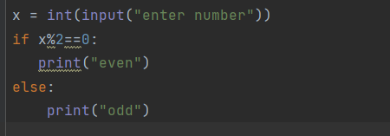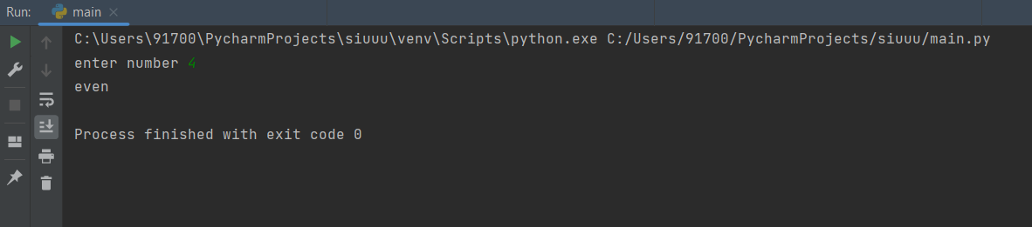

2)Write a program to implement do while using while loop.

